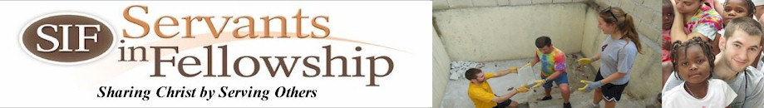

Training, New Friends, Visiting Family, Support Raising & More!
Check out what the Brubaker Clan has been up to!
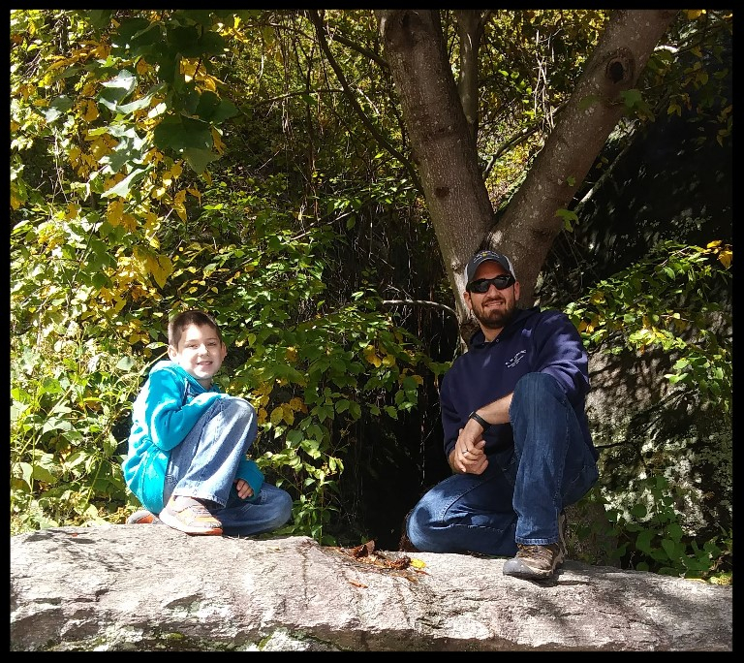
Western North Carolina is absolutely beautiful during Autumn!
We spent 4 weeks attending classes and trainings at the Center for Intercultural Training in Union Mills, NC. It was a humbling and eye opening experience for all of us. The kids loved their classes and enjoyed making new friends. Eloise and Fitsum learned how to sing "Jesus Loves Me" in several different languages. If you ask maybe they'll preform for you the next time you see them! Noah quickly gained a reputation for making the other parents nervous as he scampered 15 feet or so up the tree out front of the apartments. All three learned much and have been putting into practice some of their newly acquired knowledge. Travis & Erin had an intense 4 weeks. We learned about cross-cultural ministry and some important skills for doing life well in the midst of transition, new challenge s and new ministry. We will fondly remember the friends we gained during those weeks and we are so grateful for all those we attended CIT with as they ready to depart for their mission assignments as well.

With Weekends "off" from classes we had the chance to explore our surroundings, worship at a Haitian Church in Charlotte, and even visit some much loved family in Georgia!

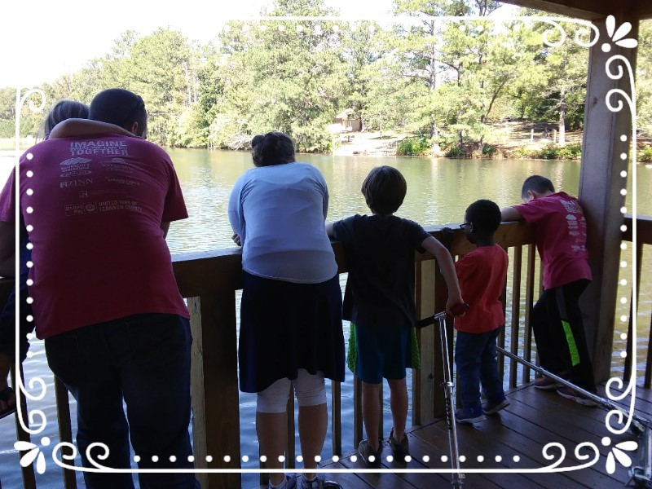
Visiting with Family in Sugar Hill, Georgia
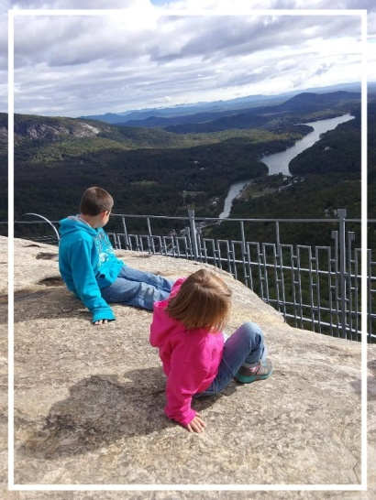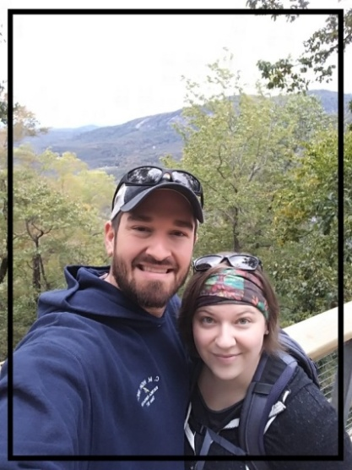
Chimney Rock, North Carolina
Our house in Haiti before some painting & repairs!
Greg & Cathie, SIF's missionaries in Haiti, are hard at work on our behalf. They have secured a home (right across the street from the current SIF guesthouse!), as well as a vehicle for us. We are so grateful to them for all their hard work and intentionality towards helping to make our family’s transition as smooth as possible.

As our family walks through our last few weeks before heading to Haiti there is much to accomplish. We have weekends away with loved ones, holidays filled with food, fun & family, and of course packing, paperwork and continuing Creole lessons. We're praying that our family remains intentional in "leaving well" as the Lord concludes this season of our lives.
We also recognize and grieve with our families as they work through the loss of our physical presence in their lives. A friend recently posted the article "Senders Make Sacrifices Too". The author puts into words what so many families and friends of missionaries go through as their world is altered too. It's well worth the read (and only takes about 5 minutes).
https://www.alifeoverseas.com/senders-make-sacrifices-too/?fbclid=IwAR0zCj0ntqem4TwosDpb1y7bHPnVMlGg71HaBv7voZvVHa2RbWQXXKzv_Cw

Prayers & Praises
"Prayer is the conduit through which God's power is released and His will is brought to earth as it is in Heaven" - Sharon Jaynes
Praises:
*Our God is alive & active! Noah experienced spiritual warfare in the form of night terrors during our time in North Carolina, something he has never had before. Satan foolishly thought he could get to us. But our Spiritual family rallied strong, our prayer warriors took up audience with our heavenly Father, and we renounced Satan. Noah learned how to claim his peace in the name of Jesus. He learned that he has the power to renounce Satan in the name of his Savior. He memorized verses to fight the fear and praise & worship music played in their room all night. It was incredible to watch our 8 year old recognize the power he has in the Lord. Thank you to many of you who prayed for us during those nights. Your prayers do not fall on deaf ears!
*We have a house! Need we say more?
*SIF intern Colin Zimmerman will be driving our moving truck to Florida with Travis! Travis won't have to drive alone! We are so grateful for Colin in so many ways. His willingness to come alongside our family is such a blessing.
*80% monthly funding!
Prayers on Our Behalf:
*Erin's mom. Erin's mom continues to have on going health issues. Recently several things have come to light that will require more testing. Please pray for answers, treatment options and rest for her as she is in almost constant pain.
*Remaining support. Please pray with us that the Lord would raise the remaining 20% monthly support needed for our family.
*Transitions. Transitions, especially cross cultural ones, often bring stress and conflict into marriage & parenting. We ask that you cover our family in prayer as we follow where the Lord has led us.

We are so grateful for you, your prayers & your support. May you be blessed!

Learning to Serve,
Travis, Erin, Noah, Eloise & Fitsum

